

Top of Form

# [Better, Faster, Cheaper](http://www.governing.com/blogs/bfc)

**Pension Reform That Gets the Job Done**

What Arizona lawmakers have done gets at many of the most serious problems facing public pensions everywhere. Now it's up to the state's voters.

BY [CHARLES CHIEPPO](http://www.governing.com/authors/Charles-Chieppo.html) | APRIL 5, 2016

In February, I wrote that a case challenging reforms made in 2011 to Arizona's Public Safety Personnel Retirement System (PSPRS) [had made it to the state Supreme Court](http://www.governing.com/blogs/bfc/col-arizona-public-pension-state-supreme-court.html). The case is still pending, but bold new legislation has since been enacted that holds the promise of putting PSPRS back on track and serving as a national model for collaborative public-pension reform.

In just over a decade, the PSPRS went from being fully funded to having less than half the assets it needs to cover its liabilities; its unfunded liability stands at $6.6 billion. There are two major culprits. One is the all-too-common practice of basing funding calculations [on unrealistic investment return assumptions](http://www.governing.com/blogs/bfc/col-public-employee-pensions-assumed-historical-rates-return.html). The PSPRS's assumed annual rate of return was 8 percent until a recent reduction to 7.5 percent. But since 2002, ["actuarially smoothed"](https://www.soa.org/News-and-Publications/Newsroom/Press-Releases/Smoothing-Helps-Sponsors-Manage-Defined-Benefit-Volatility,--But-May-Affect-Perceptions-of-Plan-Financial-Status.aspx) returns -- the basis on which pension contribution rates are determined -- have been less than 5 percent.

The other main cause was a bizarre practice known as the permanent benefit increase (PBI). In years when investment returns were strong, money was skimmed off the top to give PSPRS retirees increases designed to partially offset inflation. The practice has a host of problems. Since it's impossible to predict the years when the fund will realize strong returns, PBI expenditures could not be anticipated or factored into funding projections, and the skimming reduced the amount of money collecting interest.

**RELATED**

* [**The Search for Consensus on Public Pension Reform**](http://www.governing.com/gov-institute/voices/col-consensus-public-pension-reform.html)
* [**The Transparency That Public Pensions Need**](http://www.governing.com/columns/smart-mgmt/col-transparency-disclosure-public-pensions-alternative-investments.html)
* [**Cities’ Pension Liabilities Are About to Look a Lot Worse**](http://www.governing.com/blogs/bfc/col-new-gasb-rule-city-pension-liabilities.html)
* [**Public Pensions’ Latest Challenge: Longer Lives**](http://www.governing.com/blogs/bfc/col-public-pension-funding-longevity.html)
* [**Playing Fair With Public-Employee Unions**](http://www.governing.com/blogs/bfc/col-public-employee-unions-fairness-wisconsin-missouri.html)

PBI benefits were also allocated inequitably. Rather than basing payments on a retiree's monthly benefit, all received the same amount. Finally, the increases doled out during good times were permanent and became part of a retiree's base benefit.

The latest PSPRS reform takes a number of steps to address these problems, most of which will apply to employees hired on or after July 1, 2017. The maximum annual salary for purposes of pension calculation will be reduced from $265,000 to $110,000. Current and future pension costs will be split evenly between employers and employees. And the number of labor representatives on the PSPRS board will increase to recognize the equal risk and cost-sharing between employees and employers.

New employees will choose between a defined-contribution plan and a hybrid that combines defined-benefit and defined-contribution elements. Those employees can't begin to collect until age 55 (up from 52-1/2), although they can retire at any time. This is an important change because it makes pensions portable, so employees wanting to move on no longer have an incentive to stick around until they vest in the retirement plan.

Top of Form

Bottom of Form

And what about PBIs? They will be replaced by a traditional cost-of-living adjustment (COLA) based on the Phoenix-area consumer price index. Once CPI increases are established, the COLA is calculated as part of the normal cost to be funded that year by employer and employee contributions. For those hired on or after July 1, 2017, the maximum annual COLA limits are 2 percent if PSPRS is at least 90 percent funded, 1.5 percent if it's 80 percent funded and 1 percent if it has 70 percent of the assets needed to cover its accrued liabilities; there will be no adjustment if PSPRS falls below a 70 percent funded ratio. (Pre-reform unfunded liability will not be taken into account.)

The comprehensive reform includes a number of other fiscally responsible provisions. Any future benefit increases that create unfunded liability must be paid in full at the time of enactment. Any unfunded liability created by new hires is to be amortized over 10 years, and a 20-year schedule is established for retiring legacy unfunded liability.

Despite new employees' shouldering of a larger percentage of pension costs, their contributions under the law are projected to be smaller than what current employees pay, since the new system will be less expensive. In all, the new system is expected to save $1.5 billion -- more than one-third of accrued liability -- over 30 years.

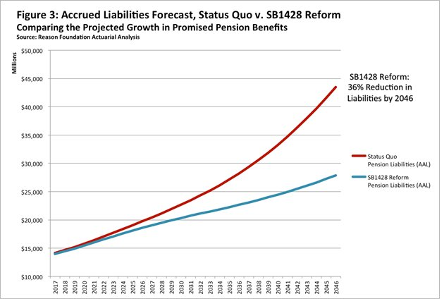The one catch is that replacing the PBIs with a COLA system will require voters to amend a provision of the Arizona constitution decreeing that "public retirement benefits shall not be diminished or impaired." The measure will appear on the statewide ballot in May and has the backing of public safety unions, municipal employers and Gov. Doug Ducey.

Just as amazing as the scope of Arizona's reform was the way in which it was achieved. It passed overwhelmingly in the state House and unanimously in the Senate after a year-long collaborative process that involved lawmakers, public safety unions and the Reason Foundation, a libertarian think tank, among others. *Arizona Republic*columnist Robert Robb rightly described it as a "paradigm-buster," writing that "public employee unions and libertarian wonks blazed new ground on a difficult and emotional topic that is producing paralysis around the country."

Each state has its own political dynamics, but most face significant pension challenges. Arizona's paradigm-buster may not be achievable everywhere, but it does offer an approach that some could use to make real progress on a problem that often seems intractable and will only get worse if it isn't addressed.

[Charlie_Chieppo@hks.harvard.edu](mailto:Charlie_Chieppo@hks.harvard.edu)



#### [Charles Chieppo](http://www.governing.com/authors/Charles-Chieppo.html)

*Charles Chieppo is a research fellow at the Ash Center of the Harvard Kennedy School.*

Part of

#### Better Faster Cheaper

with [*Steve Goldsmith*](http://www.hks.harvard.edu/about/faculty-staff-directory/stephen-goldsmith)

Harvard Kennedy School

