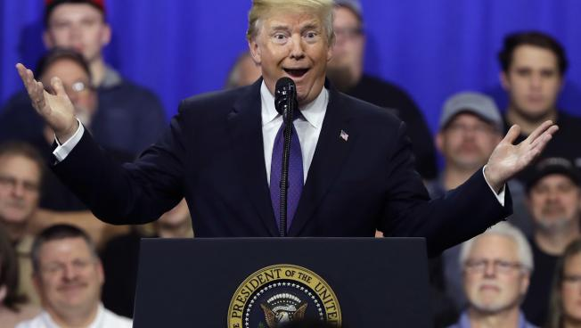

President Donald Trump speaks on tax policy during a visit to Sheffer Corporation, Monday, Feb. 5, 2018, in Blue Ash, Ohio.

Credit: Evan Vucci/AP
COMMENTARY

Overkill: When Trump Bashing Subverts The Public Interest
February 6, 2018
CHARLES CHIEPPO

The Dangerous Case of Donald Trump: 27 Psychiatrists and Mental Health Professionals Assess a President has caused considerable stir.
At it’s core, the book is based on the reasonable idea that presidents should be required to undergo a uniform physical and mental examination annually.
This debatable but essentially commonsense measure, however, will not gain any traction because of the overweening smugness and naked partisanship of its contributors.
I will leave it to those in the mental health community to debate the merits of the “Goldwater Rule,” which inhibits mental health professionals from diagnosing public officials they have not personally examined, or the question of whether evaluating President Trump’s dangerousness is different from diagnosing him.
My frustration is that the book will only validate the president’s campaign claim that he “could stand in the middle of Fifth Avenue and shoot somebody” without losing any votes.
The book’s tone is straight out of central casting, the perfect target for Trump supporters who rail against “fake news” and tout “alternative facts.”
It’s littered with parenthetical phrases like “I have profound doubts about how sincerely motivated Mr. Trump is to pursue the interests of the truly powerless” and declarations such as “There is considerable evidence that absolute tyranny is (Trump’s) wet dream.”
They may be right. And I don’t disagree with conclusions that Trump is delusional and likely suffers from lack of empathy and narcissistic personality disorder.
The disinterestedness we expect from the healing professions instantly evaporates when you combine the tone of the prose with the fact that there isn’t a single Republican among the book’s 27 contributors. Hubris, after all, is a self-inflicted wound. (When one contributor was asked about the book’s lack of partisan diversity on WGBH-TV’s “Greater Boston,” the best he could offer was that he thought one Republican was invited to participate.)
The Dangerous Case of Donald Trump is symbolic of our polarized times. Its contributors bring to mind the old story of the woman who was shocked by Richard Nixon’s reelection in 1972 because everyone she knew voted for George McGovern. It’s what happens when people never interact with anyone who has different views. They slowly come to believe that the opinions of those in their circle are universal.
The tragedy of The Dangerous Case of Donald Trump is not that its contributors are wrong. Did we really believe Donald Trump’s personal physician last year when he told us that the overweight septuagenarian was “the healthiest individual ever elected to the presidency?”
The bottom line is this: An opportunity has been squandered to establish physical and emotional identifiers for chief executives who – like our sitting president – constitute real and present dangers.
Charles Chieppo is the principal of Chieppo Strategies LLC, a public policy writing and communication firm.

