GUEST COLUMN: Bringing rail to Gillette a bad move
- BY GREG SULLIVAN and CHARLES CHIEPPO
- March 8, 2017

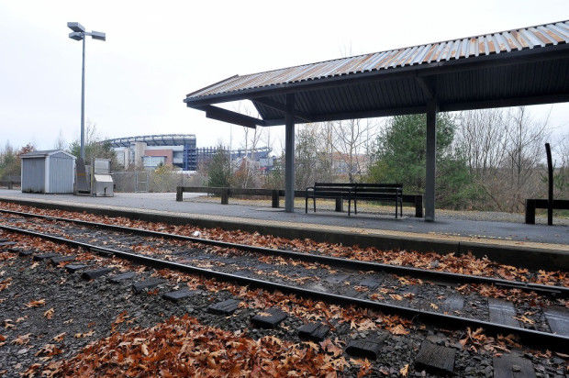

The train platform at Gillette Stadium in Foxboro.

Thus far, the MBTA's Fiscal and Management Control Board (FMCB) has made steady progress in its effort to revitalize the troubled transit agency. But sometimes, what you say no to is as important as what you do, and that is certainly the case when it comes to a proposed pilot program to bring daily commuter rail service to Gillette Stadium in Foxboro.
The T has provided service to the stadium on Patriots game days since 1989. Two years ago, the Massachusetts Department of Transportation purchased the tracks needed to facilitate four daily round trips between South Station and Foxboro.
Regular commuter rail service would certainly benefit Patriots owner Robert Kraft, but the taxpayers would be the ones subsidizing it. The Kraft Group owns Gillette and much of the area surrounding the stadium that has been designated as one of 16 "Growth Districts" in which the commonwealth hopes to expedite commercial and residential development.
A 2010 feasibility study that looked at options for bringing a commuter rail stop to Foxboro found that capital costs associated with full-time service, such as a new station and infrastructure improvements to existing tracks that can't support higher speeds, could run as high as $84 million. Seven years later, the number would undoubtedly be higher, and it doesn't include maintenance costs and an operating subsidy that the study says could top $10 per ride.
The study brings back memories of the MBTA's disastrous decision to spend $600 million in state money to build the Greenbush commuter rail line to the South Shore with no federal contribution. Ridership on the line has never even reached half of what was projected.
As with Greenbush, a high percentage of Foxboro riders are expected to be drawn from other transit lines, which comes as no surprise given that there are already four commuter rail stops nearby. As a result, the service would do little to reduce highway congestion or improve air quality.
Given the lack of wider benefits, if the Kraft Group wants Foxboro commuter rail service, they should pay for the lion's share of it. But thus far they are only offering a $200,000 subsidy, which would cover just a miniscule fraction of building, operating and maintaining the line.
Approving this pilot would also be a return to the policies that helped land the MBTA in the mess that was unmasked by the snow and cold of 2015. For decades, the T had been among the fastest-growing major U.S. transit authorities, with no revenue source to pay for the additional capital and operating costs. The authority responded by robbing Peter to pay Paul; pulling money from maintenance to fund expansion and piling up massive debt.
Since it took over management of the MBTA in 2015, the FMCB has made impressive progress toward putting the troubled transit agency back on the right track. Thanks to actions that range from renegotiating the T's contract with its biggest union to the strategic use of outsourcing, the authority finally appears to be on course to achieve financial sustainability and provide better customer service.
Approving the pilot program to provide daily commuter rail service to Gillette Stadium would represent a step back to the bad old days of approving projects the MBTA can't afford to build, operate or maintain, and that offer little in return for taxpayers' investment.
Greg Sullivan is research director and Charles Chieppo is a senior fellow at Pioneer Institute, a Boston-based think tank.

