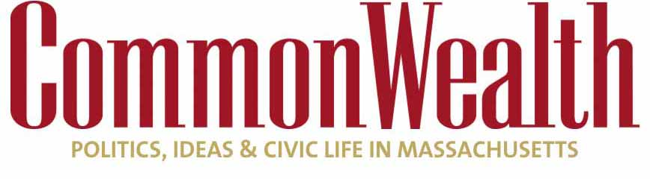
POLITICS/ OPINION

Ruling could have big impact in Massachusetts

Union PACs may see some of their money dry up
CHARLES CHIEPPO Jun 27, 2018
43
THE UNITED STATES has a single constitution, but interpretations of that document handed down by federal courts often have divergent impacts across the country.

Such is the case with the Supreme Court’s recent decision in Janus v. AFSCME. The Court overturned a 41-year-old ruling and found that an Illinois public employee who chose not to join a union could not be compelled to pay the collective bargaining unit an “agency fee” to cover the cost of contract negotiations and workplace grievance procedures.

Little will change in 28 “right-to-work” states where employees already can’t be compelled to pay dues or fees to a union they choose not to join. But thanks to organized labor’s outsized political clout in Massachusetts, there are few states where Janus will have a bigger impact.

Here, 18 of the 20 political action committees (PACs) that give the most to candidates for state and county offices are labor organizations, according to the latest data available from the Massachusetts Office of Campaign and Political Finance. The overwhelming majority of office holders are Democrats, and 85 percent of all PAC contributions go to Democratic candidates. That percentage is undoubtedly higher among contributions from labor PACs.
The result is that when it comes to public employee labor negotiations, public officials who are supposed to represent taxpayers are actually bargaining with their own benefactors. To say that this Tammany Hall-like nexus between labor and the dominant political party doesn’t serve taxpayers well would be an understatement.

The issue is not that organized labor is bad, but that democracy is harmed when any one group gains too much political power.
The most immediate local impact of the Janus ruling may come from a group of educators who have petitioned the Commonwealth’s Supreme Judicial Court to hear a case challenging the payments they are compelled to make to unions as a condition of their employment. Not all teachers agree with the positions their unions take on an array of political issues ranging from health care to the environment; nor do all support their unions’ knee-jerk opposition to testing and charter public schools, for that matter.

Nationally, organized labor’s political clout has been on the wane for decades, and it should be noted that some places would benefit from labor having a stronger voice.
Meet the Author

Charles Chieppo
Guest Contributor
Bio » Latest Stories »
But it’s clear that unions are the political puppeteers in Massachusetts. Here, the Supreme Court’s ruling in Janus v. AFSCME will help restore the balance that is so critical to a healthy democracy.

Charles Chieppo is a senior fellow at the Pioneer Institute, a Boston-based public policy think tank.

