NEW YORK DAILY NEWS

Opening day in this reopening year
By CHARLES CHIEPPO
APR 01, 2021 AT 5:00 AM
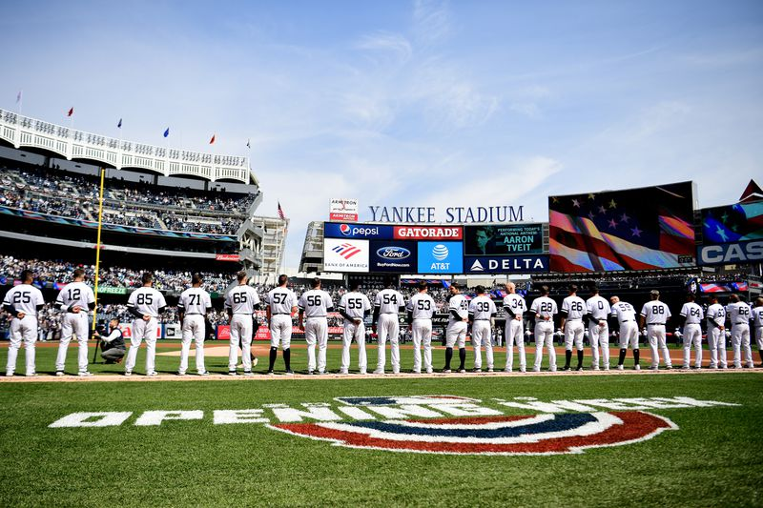
The New York Yankees stand for the National Anthem before the game against the Baltimore Orioles on Opening Day at Yankee Stadium on March 28, 2019 in the Bronx borough of New York City. (Sarah Stier/Getty Images)

The ritual of Opening Day of the baseball season is special this year. We had baseball amid the pandemic last year — sort of. Instead of fans in the ballpark, it was cardboard cutouts and piped-in crowd noise. This April, the fans return, albeit in limited numbers at first.

I confess that the memory of how special a day at the ballpark could be had dimmed for me until a 2008 trip to Yankee Stadium. Knowing the Stadium would close after that season, I was determined to share with my then-8-year-old son the kind of experience I had with my dad growing up in Connecticut in the 1960s and 70s. Unlike me, the only pleasure Michael took from baseball was in my frustration, as a Yankee fan living in the Boston area, with their increasingly frequent losses to the Red Sox.

Knowing only the at-best mediocre teams of the late 60s and early 70s as a kid, the Yankee dynasty seemed as remote to me as a Model T. But that didn’t tarnish the excitement of trips to Yankee Stadium with my dad.

There was still some memorable baseball to be enjoyed. Like the 1970 doubleheader (two nine-inning games for one admission back then!) in which Yankee center fielder Bobby Murcer tied a major league record by hitting home runs in four consecutive at-bats. Before that was the thrill of seeing Mickey Mantle hit one of his last home runs after injuries and hard living had snuffed out his greatness too soon.

Past triumphs felt more real during the annual Old Timers’ Day, which we never missed. The likes of Joe DiMaggio, Yogi Berra, and later Mantle, would play a two-inning exhibition. After some of the old glory was recaptured in the late 70s, Yankee owner George Steinbrenner chose Old Timers’ Day in 1978 to announce Billy Martin’s first of many returns as Yankee manager.

One night during that summer of 2008, I learned that the next day was Red Sox day at Michael’s Cub Scout camp. What greater indignity could befall a Yankee fan than a last-minute dash to Marshalls for a Red Sox hat and T-shirt? Later, he gleefully regaled me with stories of how the festivities included using a Yankees logo as the bullseye during BB gun target practice.

The first evidence of just how much things had changed in 40 years came when I discovered that every weekend home game for the 2008 season was virtually sold out. I had just about given up on getting to the Stadium when a lifelong friend who still lives in our New Haven-area hometown tracked down six tickets. His family, Michael and I would be going to a game after all. My dad paid $4.50 per ticket for box seats to be among a very intimate group of fans in 1966 and 67; we would be paying $95 a shot to be part of “The Final Season.”

If nothing else, Michael enjoyed the elevated subway ride to the Stadium. Once inside, he took an immediate interest in the concessions. I lost two innings finding the one stand that sold a few french fries for $5 — anything to make the day special. After a couple of $4.75 hot dogs, a $10 beer (for me), $5 peanuts, another $5 for lemonade and $4.50 for cotton candy — eye-popping prices for 2008 — I remembered why my dad packed us sandwiches.

His appetite temporarily sated, Michael settled in for what began as a quick, low-scoring game — great for a fan, not so much for a marginally interested 8-year-old. By the end of the sixth inning, he announced he was bored and asked when we could go. This triggered one of those parental crises: Did the importance I attached to this experience have more to do with reliving my own childhood than with his?

Then a funny thing happened. The Yankees tied the game, bringing the crowd of more than 50,000 to life. A 13-inning battle was capped by a two-out walk-off hit by a young outfielder named Brett Gardner for a Yankee win. The image of one of my friend’s sons was even projected on the jumbotron. Michael spent the last six innings on his feet, and I felt vindicated.

Standing on the subway platform after the game, I called my 89-year-old father to tell him about it. Like any good child of the depression, his first words were, “you really paid $10 for a beer?”

Dad is gone and Michael turns 21 this summer. But that day in 2008 remains a vivid reminder of the joys of a day at the ballpark. It sure will be nice to have that back.

Chieppo is the principal of Chieppo Strategies, a Boston-area public policy writing and communication firm.

