

CHARLES CHIEPPO | OPINION

School closings are tough but necessary

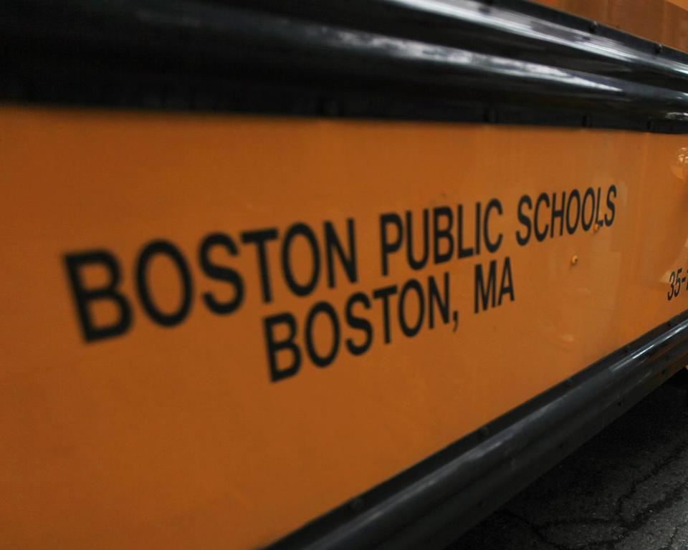

PAT GREENHOUSE/GLOBE STAFF/FILE

**By Charles Chieppo**   APRIL 25, 2016

WITH ENROLLMENT at Boston Public Schools (BPS) falling, the school committee voted to close 22 schools as the first step in a modernization plan to reduce facilities costs and maximize the resources going directly into classrooms.

Sound familiar?

The catch: The year was 1952, which proves there’s some truth to the old adage that the more things change, the more they stay the same.

Late last year, an independent audit found that BPS buildings have a huge amount of excess capacity, not a surprise, given that enrollment has shrunk by nearly half since the early 1970s. Depending on whom you ask, right-sizing the district would save between $20 million and $90 million annually. From a policy perspective, then, school consolidation is a no-brainer. But the politics are a different story.

Boston’s 1952 effort was spearheaded by the New Boston Committee, a good-government group that sprang up after James Michael Curley was finally dispatched once and for all in the 1949 mayoral election. Two years later, most of the winners of city council and school committee elections were NBC endorsees. The group and its founder – Jerry Rappaport, who went on to become the developer for Boston’s controversial West End project – were on top of the world.

But that all unraveled with their embrace of school closings. By 1953 the plan was dead, done in by opposition from affected parents, as well as from teachers and other school personnel who would have faced layoffs. A headline from the now-defunct Boston Post correctly declared that the NBC was “finished as an effective force in Boston politics.”

Boston isn’t the only place where closing and consolidating schools is hard. Between 2007 and 2008, former Washington D.C. schools Chancellor Michelle Rhee shuttered 23 schools in response to plummeting enrollment. The 2010 city election became a referendum on her tenure. D.C. Mayor Adrian Fenty, who appointed Rhee and staunchly supported her, was defeated in the Democratic primary.

Declining enrollment took such a toll in Philadelphia that one city school with a capacity of 1,071 students was operating with only 193. Add to that a budget crisis so severe that schools nearly failed to open on time in both 2013 and 2014. But even then, a plan to close 37 schools was ultimately whittled down to 23.

Recent demonstrations against proposed cuts at BPS have made headlines, but a new report from the Boston Municipal Research Bureau finds that the city’s school budget has increased by more than 20 percent over the last five years and in excess of 40 percent over the last decade.

An additional $20 million to $90 million per year would go a long way to alleviate future school funding crunches. Such consolidation should also improve educational quality. By reducing facilities-related expenses, a right-sized BPS could free up more money for what matters most: classroom instruction.

In politics, passionate minorities routinely overpower less motivated majorities. Parents whose children’s schools would close and school personnel facing layoffs would certainly be the loudest voices in the right-sizing debate.

But elected officials have a greater responsibility — and it’s to the thousands of other, largely voiceless, Boston students who would benefit from consolidation.

*Charles Chieppo is the principal of Chieppo Strategies LLC, a public policy writing and communication firm.*