TRACKING TRANSPORTATION/ TRANSPORTATION/ OPINION

Congressional delegation should butt out

Focus on T’s retirement fund, not privatization efforts
JIM STERGIOS and CHARLES CHIEPPO Apr 29, 2017
SHARE
2913
- 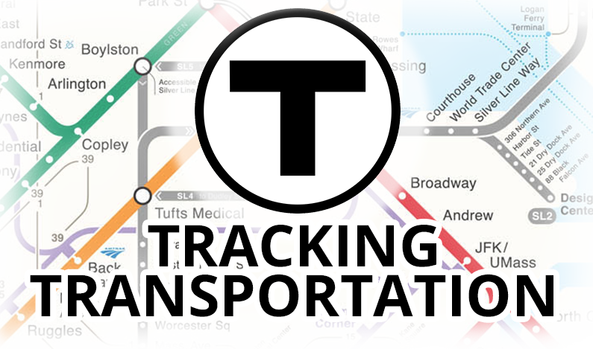

Lessons from the collapse of Bridj

HERE’S ONE THAT COULD BE A JOKE, except it actually happened. Every member of Massachusetts’ congressional delegation recently thought it would be a good idea to sign a misguided letter to Gov. Charlie Baker and Secretary of Transportation Stephanie Pollack urging them to avoid saving money and improving service quality at the MBTA.

The letter chides state officials for not maintaining the decades-old monopoly imposed by the Commonwealth’s anti-privatization law when it comes to the MBTA’s bus maintenance operation. “We as elected officials do not attempt to insert ourselves into the substance of collective bargaining between management and a bargaining unit,” they wrote, before proceeding to do exactly that.
The letter ignored the fact that because of a three-year exemption from the anti-privatization law, the T has come close to facing down a $250 million deficit. That translates to more money invested in the core system—signals, switches, all the stuff that makes the trains and buses work better. Is the delegation against that?
In 2015, the latest year for which data are available, the T once again had the highest maintenance costs in the nation per hour of bus operation. Reducing those costs to the average of five “peer” agencies, as determined by a database partially funded by the Federal Transit Administration, would have saved about $44 million.
MBTA maintenance costs were more than 70 percent higher than the average of the five peers. The T also had the highest vehicle maintenance labor salaries per hour of bus operations, again more than 70 percent above the average of its peers.

Outsourcing bus maintenance is a routine and growing practice throughout the transit industry, and most of the Commonwealth’s Regional Transit Authorities are among the agencies that do it. Adding to the bizarreness of the delegation’s letter is the fact that the privatized workforce will almost certainly be unionized, as is the case at every RTA that purchases bus maintenance services.
A better use of the delegation’s time and energy would be to work on saving the MBTA Retirement Fund, which is at risk of insolvency. The fund’s condition is far more important than the question of which union employees should maintain the buses.
About two thirds of T funding comes directly from taxpayers. Whenever more money is needed to keep the MBTA Retirement Fund afloat, the T is responsible for providing three quarters of it. Despite the fact that MBTA employer contributions have more than doubled over the last decade to $87 million annually, the pension’s unfunded liability has grown from less than $50 million in 2005 to over $1 billion today.
Unlike other state workers, MBTA employees are part of the Social Security system. Among public entities that are part of Social Security, the MBTA Retirement Fund is almost unique in that it isn’t an “integrated” system, meaning that pension payouts are not reduced to account for retirees’ receipt of Social Security benefits.
With a $7.3 billion maintenance backlog and billions more in debt, the T basically faces three options: Cut service, raise fares once again, or enact reforms such as restructuring the MBTA Retirement Fund as an integrated Social Security/pension system with offsets that take pension benefits into account.
Meet the Author

Jim Stergios
Guest Contributor
Bio » Latest Stories »
Meet the Author

Charles Chieppo
Guest Contributor
Bio » Latest Stories »
Massachusetts taxpayers would be far better served if, instead of seeking to score political points by urging state leaders to favor existing MBTA bus maintenance workers over their unionized private counterparts, members of the Commonwealth’s congressional delegation backed efforts that will stave off T service cuts and further fare increases. Retirement system reforms are at the top of that list.

Jim Stergios is the executive director and Charles Chieppo is the senior media fellow at the Pioneer Institute, a free-market-oriented think tank.

