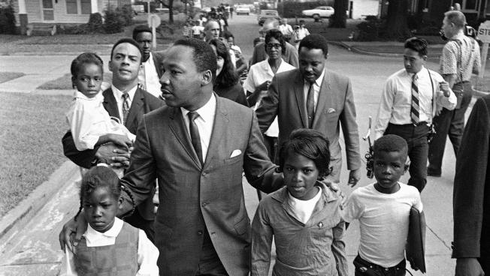

Dr. Martin Luther King Jr. walks between seven-year-old Eva Gracelemon, left, and 10-year-old Aritha Willis as he escorts black school children to formerly all-white schools in Grenada, Miss., Tuesday morning, Sept. 20, 1966.

Credit: AP photo

It's Long Past Time for High-Quality Schools In Urban Areas
November 2, 2016
CHARLES CHIEPPO
JAMIE GASS
It’s now more than half a century since Rev. Martin Luther King asked, “How long will prejudice blind the visions of men?” Standing on the steps of the Alabama State Capitol after marching from Selma to Montgomery, his optimistic answer was “not long,” because, he said, “the arc of the moral universe is long, but it bends toward justice.”
He was speaking about voting rights, but on education rights the answer is by now “too long.” It has been 62 long years since the U.S. Supreme Court’s Brown v. Board of Education of Topeka, Kans., decision. Yet, to this day, in Boston, zip code and socioeconomic indicators largely determine the futures of far too many children.
It’s been a quarter of a century since the passage of Massachusetts’ landmark Education Reform Act poured billions of dollars into urban school systems in exchange for high standards, accountability and charter schools.
There has been some improvement in urban district schools. At the same time, Massachusetts’ urban charter schools have proven to be the most effective means of decoupling zip code from educational and economic destiny.
A 2013 study from Stanford University’s Center for Research on Education Outcomes found that Boston charter schools were doing more to narrow the race- and poverty-based achievement gap than any other group of schools in the country. Statewide, the same report found that charter schools closed more than 90 percent of the wealth-based achievement gap on 2013 MCAS tests.
On 2014 MCAS tests, 18 charter schools—many of them urban—finished first in all of Massachusetts.
On the most recent state assessments (2016 PARCC/MCAS), 100 percent of the state’s urban charter public schools ranked in the highest performance levels. By comparison, in the same urban districts nearly half the students attended district schools the state defines as underperforming.
Given that track record, it’s no surprise that there are more than 32,000 Massachusetts students on charter school wait lists—16,000 in Boston alone.
A ballot initiative would allow more of these highly successful charter public schools to open their doors in our urban neighborhoods.
The arc of the moral universe is indeed long. It was nearly 70 years ago that Jackie Robinson broke baseball’s color line and more than 60 years ago in Montgomery that Rosa Parks refused to obey a white bus driver’s order to give up her seat in the “colored” section after the white section of the bus was filled.
How long? We hope the answer is “not long.” We hope Massachusetts will see the arc of the moral universe bend toward justice and give more children access to high-quality school choices. On November 8, voters will have the opportunity to do just that.
Charles Chieppo is senior fellow and Jamie Gass directs the Center for School Reform at Pioneer Institute, a Boston-based think tank.

