THE ARGUMENT

Should public employee unions be allowed to charge non-members fees to help pay for collective bargaining?
APRIL 13, 2018
YES
Joe Fonseca
Holliston resident; firefighter and President of Framingham Firefighters Local 1652
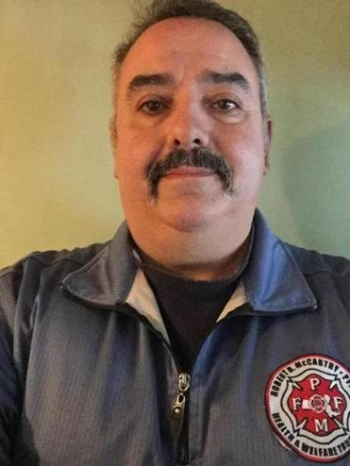
Joe Fonseca
I’m in my 30th year as a proud Framingham firefighter and I wouldn’t be where I am today without my union. Every day I put my life on the line to protect my community, and I know my co-workers – my brothers and sisters who together make up our union – have my back.
My father, one of nine kids, came to the US from Portugal for a better life. He raised four children with his union job as a laborer and taught me that the union is the path to a better life for me and my community.
The case before the US Supreme Court, Janus v. AFSCME, isn’t about individual freedom as some claim. Working men and women are wise enough to know this case is about wealth and power. And the billionaires funding the campaigns against unions want more for themselves at the expense of working people. My dad always said the union helped him get his fair slice of the pie, but today I see an elite group trying to take that slice back.
When I put my life at risk entering a burning building, I know I am better off because my union has fought tirelessly for the best safety standards, training, and equipment. The same is true for every other unionized workplace. When nurses, 911 dispatchers, and EMS workers belong to unions, they fight for staffing levels, equipment, and training that save lives. Unionized teachers advocate for better learning opportunities for students, like small class sizes and modern textbooks. There’s a reason so-called non-member fees are called “fair-share” fees. Working together as a union we fought hard for these protections and advances. They benefit everyone — members and non-members alike — so everyone should help support the bargaining that makes them possible.

I’m proud to say that every firefighter that risks his or her life alongside me is a union member. And we’re going to stay union members no matter the outcome of the case because we know that joining a union is the best shot we have at a better life for our families and a better future for our children and grandchildren.
NO
Charles Chieppo
Needham resident, senior fellow at the Pioneer Institute, a Boston-based think tank
Charles Chieppo
As the US Supreme Court weighs the case of an Illinois public employee who is challenging the fee he is required to pay to a union he has chosen not to join, a group of Massachusetts educators has petitioned the Commonwealth’s Supreme Judicial Court to hear a similar challenge. The SJC will likely hold off deciding until the Supreme Court issues a ruling.
The educators’ petition highlights why a ruling in favor of Mark Janus, the Illinois public employee who doesn’t want to join or pay an “agency fee” to his union, would be a good thing for Massachusetts (although its practical impact would vary dramatically from state to state).
Although public employees can’t be forced to join a collective bargaining unit or support union political activity, a 1977 Supreme Court ruling found they could be required to pay an agency fee to cover the cost of non-political activities like collective bargaining or workplace grievance procedures.
Should the court overturn that decision, the main focus of Massachusetts’ two teachers’ unions would likely shift to staving off potential defections like those of the educators who have petitioned the SJC. Today the unions regularly take positions that it’s safe to say some of their members disagree with, on issues ranging from health care to immigration — not to mention their opposition to charter public schools and high-stakes testing.
Shutting down the automatic flow of agency fee money that helps enable these activities and forcing unions to earn membership revenue would translate to more attention to pay and working conditions, less on politics.
This is like a civics lesson on the evils of any group amassing too much political power. The Massachusetts Legislature is overwhelmingly Democratic, and according to a state report, 18 of the 20 political action committees that gave the most to candidates for state and county offices in 2011-12 were labor organizations, and 85 percent of those PAC contributions went to Democrats.
The result that political influence — also seen on the local level — is that contract negotiations essentially consist of public officials bargaining with their benefactors, which does not serve the public interest. Ending mandatory agency fees would go a long way toward changing that and levelling the playing field in Massachusetts.

