

Top of Form

# [Better, Faster, Cheaper](http://www.governing.com/blogs/bfc)

**Public Pensions’ Not-So-Rosy Outlook**

The good news is that funding has stabilized. But a number of factors suggest that there's trouble ahead.

BY [CHARLES CHIEPPO](http://www.governing.com/authors/Charles-Chieppo.html) | JUNE 23, 2016

A new study finds that state and local pension funding has stabilized in the last year. But the news is never all good when it comes to public employees' pensions, and another report released this spring suggests that big problems may lie ahead.

In [the latest study](http://slge.org/wp-content/uploads/2016/06/The-Funding-of-State-and-Local-Pensions-2015-2020.pdf), from the Center for State and Local Government Excellence, Alicia Munnell and Jean-Pierre Aubry looked at 160 large systems that cover 90 percent of state and local government pension-plan members nationwide. They found that, in the aggregate, the plans had 74 percent of the money that was needed to fund their liabilities in 2015, up from 73 percent the year before. To provide context, the systems were 86 percent funded in 2007, before the Great Recession, and they were 103 percent funded in 2000, at the peak of the longest bull market in history.

There are a number of reasons for the slight year-over-year improvement. First, the amount that state and local governments paid into the plans rose from 86 percent of what's known as the "actuarially determined employer contribution" in 2014 to nearly 91 percent in 2015. In addition, pension-reform legislation in many jurisdictions in recent years has slowed the liability growth, which was 4.2 percent in 2015 and is expected to hold steady.

**RELATED**

* [**Pension Reform That Gets the Job Done**](http://www.governing.com/blogs/bfc/col-arizona-public-safety-pension-reform-national-model.html)
* [**The Search for Consensus on Public Pension Reform**](http://www.governing.com/gov-institute/voices/col-consensus-public-pension-reform.html)
* [**The Hidden Wall Street Fees That Could Be Costing Pensions $20 Billion a Year**](http://www.governing.com/topics/finance/gov-pensions-come-terms-with-hidden-fees-some-say-annual-exceeds-20-billion.html)
* [**Public Pensions’ Latest Challenge: Longer Lives**](http://www.governing.com/blogs/bfc/col-public-pension-funding-longevity.html)
* [**Sick-Leave Payouts: the Taxpayers’ Headache**](http://www.governing.com/blogs/bfc/col-6-figure-payouts-unused-sick-vacation-time-massachusetts.html)

There's another reason for the stabilization of state and local government pension systems: relatively strong investment performance in recent years. But that's where problems may lie.

[The April report](http://www.mckinsey.com/industries/private-equity-and-principal-investors/our-insights/why-investors-may-need-to-lower-their-sights) from the McKinsey Global Institute notes that total pension-fund investment returns in the United States and Western Europe over the last 30 years significantly outperformed the long-term 100-year average. McKinsey attributes the strong performance to lower inflation, falling interest rates and strong world GDP growth.

But going forward, the picture looks very different. Interest rates are likely to rise, and an aging world population is expected to slow GDP growth. Increased competition from emerging markets and technology disruptions that remove barriers to market entry will put downward pressure on corporate profit margins, which have been high.

Since the beginning of this century, state and local government pension plans have reduced the assumed returns on which their funding projections are based from an average of 8.1 percent to 7.6 percent. Yet actual returns were lower, even during a period of unusually strong investment performance.

The Munnell-Aubry report includes U.S. equity nominal return projections for the next 5-20 years from eight investment firms. The average of the projected returns is less than 5 percent. The 74 percent funded ratio for pensions is based on that average 7.6 percent projected rate of return.

As the table below shows, if actual returns (known as the "discount rate" because they are the rate at which investment returns allow pension funds to discount their liability) fall in coming years, state and local government pension-system funding ratios will drop precipitously.

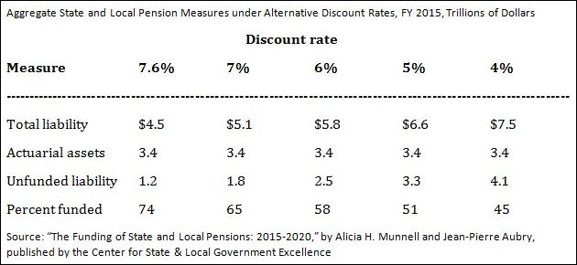Public pension funds should be congratulated for becoming more realistic about investment returns in recent years. The same goes for state and local governments that have stepped up and contributed more to their pension systems. But if future returns do indeed fall in line with historical averages, we will nonetheless find ourselves in an even deeper pension hole -- one that will make it almost impossible to avoid the existential question of whether traditional defined-benefit pensions remain a viable option going forward.

[Charlie_Chieppo@hks.harvard.edu](mailto:Charlie_Chieppo@hks.harvard.edu)



#### [Charles Chieppo](http://www.governing.com/authors/Charles-Chieppo.html)

*Charles Chieppo is a research fellow at the Ash Center of the Harvard Kennedy School.*

Part of

#### Better Faster Cheaper

with [*Steve Goldsmith*](http://www.hks.harvard.edu/about/faculty-staff-directory/stephen-goldsmith)

Harvard Kennedy School

