

[**Chieppo: Hotel project a sign of BCEC success**](http://www.bostonherald.com/opinion/op_ed/2017/04/chieppo_hotel_project_a_sign_of_bcec_success)

New management brought fiscal sanity, fun on D St.

[**Charles Chieppo**](http://www.bostonherald.com/users/charles_chieppo) Tuesday, April 25, 2017

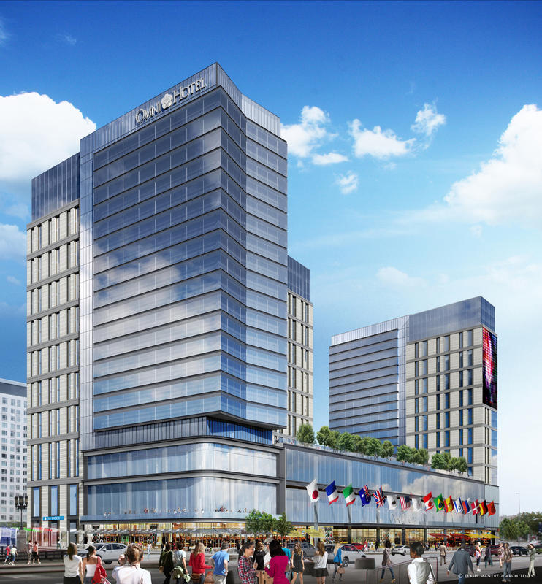

Credit: Courtesy

DIGS FOR CONVENTIONEERS: Omni Hotel plans call for two 20-story towers on a 2-acre Massachusetts Port Authority-owned site under a 90-year lease.

FacebookTwitterGoogle+Reddit

The recent announcement that an Omni hotel with more than 1,000 rooms will rise next to the Boston Convention & Exhibition Center is good news for the local hospitality industry. It’s also the most public benefit to emerge from a largely behind-the-scenes transformation of the Massachusetts Convention Center Authority.

Since its 2004 opening, the BCEC has been plagued by a dearth of proximate hotel rooms. Having to shuttle unhappy customers from other parts of the city and beyond doesn’t exactly give Boston a leg up in the hyper-competitive convention industry — and when Back Bay hotels are filled with people attending BCEC events, the Hynes Convention Center is all but unable to host events.

Still, area boosters have long pushed to put the cart before the horse, proposing to expand the BCEC and use public subsidies to entice needed hotel development.

Sanity returned in 2015, when Gov. Charlie Baker put the planned expansion on hold and hospitality veteran David M. Gibbons was selected to head the convention center authority. A comprehensive study Gibbons commissioned confirmed that the authority’s most pressing need is more hotel rooms within walking distance of the BCEC.

The Omni is the fruit of the convention authority’s focus on hotels — and a collaboration with the Massachusetts Port Authority, which just granted Omni a 90-year lease on the land in return for about $100 million and a share of revenue.

The hotel will connect via tunnel to the BCEC, and be developed *without* a public subsidy. It will also include 120,000 square feet of meeting space which, for a destination like Boston that relies on professional meetings rather than big trade shows, is far more important than cavernous exhibit space.

The hotels-first strategy is just one of the changes at the authority. Gibbons has streamlined operations, generating about $3.5 million in internal savings. In two years, the authority’s state subsidy fell from over $20 million to about $6 million.

Every dollar not used to subsidize operations is a dollar freed up for capital investments. As the BCEC and the Hynes grow older, they require more maintenance. And as the MBTA taught us, we ignore those needs at our peril.

Another obligation too often overlooked by the public sector is post-employment benefits like retiree health care. As with maintenance, the longer it’s ignored, the more expensive it becomes. Gibbons has implemented a plan to address that liability.

Since it opened in 2014, crowds have flocked to the Lawn on D, an outdoor recreation space adjacent to the BCEC. But it was also a drain on the convention authority’s finances, costing upwards of $2 million annually to operate. After cutting back on higher-cost programming and increasing restaurant revenue, the loss fell to about $250,000 last year and attendance *increased*.

Just as elected officials are drawn to cutting ribbons on new projects at the expense of maintaining existing assets, convention industry leaders are all too often unable to resist the siren song of expansion. A large hotel to be connected to the Boston Convention & Exhibition Center and developed without a public subsidy is the highest-profile example of how a new regime at the Massachusetts Convention Center Authority is demonstrating the benefits of listening to the market instead of succumbing to an edifice complex.

*Charles Chieppo is the principal of Chieppo Strategies LLC and a former vice chair of the Massachusetts Convention Center Authority.*